

**Batter Frying Instructions**

1. 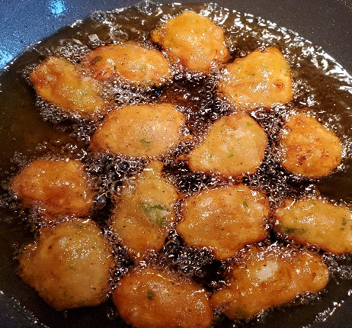After thawing mix batter before cooking
2. Heat 4 to 5 cups of oil I large pot/skillet or deep fryer to 350 degrees
3. Use a table/tea spoon to scoop batter and then drop them in hot oil
4. If the oil is too hot turn off burner (you don’t want the batter cooking too quickly, otherwise fritter will look cooked outside and remain raw on the inside)
5. While cooking, turn fritter constantly until both sides are an even golden brown
6. This should take about 15 minutes
7. Remove fritter from pan and let sit on paper towel to absorb oil
8. Use Bahama Mama Sauce to garnish
9. Bon Appetit!